**Differences in dissolved organic matter composition between rivers and estuaries is conserved across freshwater and saltwater coastal regions**

J. Alan Roebuck, Jr.1, Allison N. Myers-Pigg1,2*, Peter Regier3, Nicholas D. Ward3, Matthew J. Cooper4, Kenneth M Kemner5, Amy M. Marcarelli6, Elizabeth C. Minor7, Michael Philben8, Bongkeun Song9, Rodrigo Vargas10, Jianqiu Zheng1, EXCHANGE Consortium

1Biological Sciences Division, Pacific Northwest National Laboratory

2Department of Environmental Sciences, College of Natural Sciences & Mathematics, University of Toledo

3Coastal Sciences Division, Pacific Northwest National Laboratory

4Department of Biology, Grand Valley State University

5Bioscience Division, Argonne National Laboratory

6Department of Biological Sciences, Michigan Technological University

7Department of Chemistry and Biogeochemistry and Large Lakes Observatory, University of Minnesota

8Geological and Environmental Science Department, Hope College

9Ecosystem Health Section, Virginia Institute of Marine Science

10Department of Plant and Soil Sciences, University of Delaware

**Table S1:** Site level metadata for each sampling location. Additional metadata is available at Pennington et al., 2023

|  |  |  |  |  |  |  |
| --- | --- | --- | --- | --- | --- | --- |
| **ID** | **Latitude** | **Longitude** | **System** | **Region** | **Water Type**  **(Consortium Reported)** | **Water Type** |
| K004 | 41.502 | -83.0435 | Great Lakes | Great Lakes | Tidal River | Riverine |
| K008 | 41.3824 | -82.5147 | Great Lakes | Great Lakes | Lacestuary | Estuarine |
| K009 | 41.3754 | -82.5164 | Great Lakes | Great Lakes | Lacestuary | Estuarine |
| K010 | 41.3734 | -82.5091 | Great Lakes | Great Lakes | Lacestuary | Estuarine |
| K011 | 41.3772 | -82.51 | Great Lakes | Great Lakes | Lacestuary | Estuarine |
| K012 | 43.5831 | -83.688 | Great Lakes | Great Lakes | Tidal Stream | Riverine |
| K013 | 43.9688 | -83.8603 | Great Lakes | Great Lakes | Lake | Estuarine |
| K015 | 37.4147 | -76.7161 | Chesapeake Bay | Mid-Atlantic | Estuary | Estuarine |
| K016 | 37.3044 | -76.5539 | Chesapeake Bay | Mid-Atlantic | Estuary | Estuarine |
| K017 | 37.5678 | -76.8867 | Chesapeake Bay | Mid-Atlantic | Tidal River | Riverine |
| K018 | 37.2192 | -76.4136 | Chesapeake Bay | Mid-Atlantic | Estuary | Estuarine |
| K019 | 46.6533 | -92.2266 | Great Lakes | Great Lakes | Lacestuary | Estuarine |
| K021 | 41.6056 | -83.1526 | Great Lakes | Great Lakes | Lacestuary | Estuarine |
| K022 | 41.4629 | -82.9971 | Great Lakes | Great Lakes | Lacestuary | Estuarine |
| K023 | 38.8014 | -76.7033 | Chesapeake Bay | Mid-Atlantic | Tidal Stream | Riverine |
| K024 | 38.2087 | -75.8044 | Chesapeake Bay | Mid-Atlantic | Estuary | Estuarine |
| K025 | 38.8873 | -76.5621 | Chesapeake Bay | Mid-Atlantic | Tidal Stream | Riverine |
| K026 | 37.7106 | -75.6117 | Chesapeake Bay | Mid-Atlantic | Tidal Stream | Riverine |
| K029 | 39.4188 | -75.3786 | Delaware Bay | Mid-Atlantic | Tidal Stream | Riverine |
| K030 | 39.0884 | -75.4374 | Delaware Bay | Mid-Atlantic | Tidal Stream | Riverine |
| K033 | 47.1041 | -88.5153 | Great Lakes | Great Lakes | Lacustuary | Estuarine |
| K034 | 38.7746 | -75.9752 | Chesapeake Bay | Mid-Atlantic | Tidal Stream | Riverine |
| K035 | 38.5922 | -76.1307 | Chesapeake Bay | Mid-Atlantic | Estuary | Estuarine |
| K036 | 39.0412 | -76.2218 | Chesapeake Bay | Mid-Atlantic | Estuary | Estuarine |
| K037 | 37.5569 | -76.9731 | Chesapeake Bay | Mid-Atlantic | Tidal River | Riverine |
| K038 | 37.3264 | -77.2078 | Chesapeake Bay | Mid-Atlantic | Tidal Stream | Riverine |
| K040 | 37.4559 | -75.8335 | Chesapeake Bay | Mid-Atlantic | Tidal Stream | Riverine |
| K041 | 37.4557 | -75.8334 | Chesapeake Bay | Mid-Atlantic | Tidal River | Riverine |
| K042 | 39.8816 | -75.2665 | Delaware Bay | Mid-Atlantic | Tidal Stream | Riverine |
| K043 | 39.062 | -75.394 | Delaware Bay | Mid-Atlantic | Estuary | Estuarine |
| K045 | 39.9886 | -74.8467 | Delaware Bay | Mid-Atlantic | Tidal River | Riverine |
| K046 | 39.0892 | -75.4365 | Delaware Bay | Mid-Atlantic | Tidal Stream | Riverine |
| K047 | 43.4162 | -86.3489 | Great Lakes | Great Lakes | Lacestuary | Estuarine |
| K048 | 39.8803 | -75.2667 | Delaware Bay | Mid-Atlantic | Tidal Stream | Riverine |
| K049 | 42.6708 | -86.2107 | Great Lakes | Great Lakes | Lake | Estuarine |
| K050 | 37.3344 | -77.2072 | Chesapeake Bay | Mid-Atlantic | Tidal Stream | Riverine |
| K051 | 38.5747 | -76.2191 | Chesapeake Bay | Mid-Atlantic | Tidal Stream | Riverine |
| K052 | 38.1595 | -75.7905 | Chesapeake Bay | Mid-Atlantic | Tidal Stream | Riverine |
| K053 | 38.812 | -76.7083 | Chesapeake Bay | Mid-Atlantic | Tidal Stream | Riverine |
| K054 | 38.9677 | -75.3703 | Delaware Bay | Mid-Atlantic | Tidal Stream | Riverine |
| K055 | 39.8055 | -75.2077 | Delaware Bay | Mid-Atlantic | Tidal stream | Riverine |
| K056 | 39.1838 | -74.8511 | Delaware Bay | Mid-Atlantic | Tidal Stream | Riverine |
| K058 | 39.2576 | -75.0905 | Delaware Bay | Mid-Atlantic | Tidal Stream | Riverine |
| K059 | 38.4292 | -76.2374 | Chesapeake Bay | Mid-Atlantic | Open Water | Estuarine |
| K060 | 39.3259 | -75.4749 | Delaware Bay | Mid-Atlantic | Estuary | Estuarine |
| K061 | 39.2157 | -75.4618 | Delaware Bay | Mid-Atlantic | Tidal Stream | Riverine |
| K062 | 38.8753 | -76.5513 | Chesapeake Bay | Mid-Atlantic | Estuary | Estuarine |

**Table S2:** Site-level data for dissolved organic carbon (DOC), pH, salinity, alkalinity, total suspended solids (TSS), total dissolved nitrogen (TDN), and redox potential (ORP)

|  |  |  |  |  |  |  |  |
| --- | --- | --- | --- | --- | --- | --- | --- |
| **ID** | **DOC (mg/L)** | **pH** | **Salinity (psu)** | **TDN (mg/L** | **TSS (mg/L)** | **Alkalinity**  **(mg/L CaCO3)** | **ORP (mV)** |
| K004 | 7.31 | 7.69 | 0.25 | 2.54 | 45 | 102 | 360 |
| K008 | 2.97 | 7.74 | 0.20 | 0.43 | 31 | 111 | 315 |
| K009 | 7.03 | 7.58 | 0.26 | 0.67 | 221 | 166 | 305 |
| K010 | 7.20 | 7.57 | 0.30 | 1.24 | 78 | 170 | 291 |
| K011 | 3.28 | 7.83 | 0.20 | 0.54 | 39 | 108 | 262 |
| K012 | 15.01 | 6.81 | 0.27 | 2.29 | 1234 | 164 | 350 |
| K013 | 7.73 | 7.69 | 0.31 | 2.58 | 296 | 199 | 296 |
| K015 | 4.50 | 7.29 | 16.05 | 0.56 | 63 | 67 | 334 |
| K016 | 5.06 | 7.12 | 20.51 | 0.58 | 50 | 74 | 311 |
| K017 | 5.08 | 7.07 | 2.70 | 0.44 | 89 | 33 | 328 |
| K018 | 3.17 | 7.77 | 20.46 | 0.43 | 37 | 73 | 314 |
| K019 | 7.62 | 7.90 | 0.18 | 0.49 | 5 | 105 | 322 |
| K021 | 30.37 | 7.52 | 0.27 | 1.96 | 56 | 167 | 298 |
| K022 | 27.65 | 7.28 | 0.22 | 1.74 | 17 | 126 | 322 |
| K023 | 3.58 | 7.03 | 0.20 | 0.47 | 12 | 52 | 311 |
| K024 | 7.63 | 6.87 | 12.93 | 0.56 | 18 | 63 | 325 |
| K025 | 5.78 | 6.44 | 2.65 | 0.74 | 28 | 40 | 334 |
| K026 | 6.33 | 7.38 | 31.86 | 1.44 | 382 | 131 | 347 |
| K029 | 5.07 | 6.62 | 5.01 | 0.77 | 133 | 106 | 301 |
| K030 | 7.00 | 6.70 | 13.31 | 0.85 | 51 | 76 | 354 |
| K033 | 4.25 | 7.55 | 0.15 | 0.44 | 4 | 89 | 322 |
| K034 | 5.89 | 6.92 | 1.75 | 0.83 | 19 | 57 | 180 |
| K035 | 4.21 | 7.07 | 10.96 | 0.54 | 18 | 66 | 308 |
| K036 | 4.04 | 7.97 | 6.60 | 0.57 | 12 | 86 | 300 |
| K037 | 5.94 | 6.67 | 0.41 | 0.38 | 9 | 28 | 348 |
| K038 | 4.50 | 7.07 | 0.10 | 0.34 | 34 | 48 | 350 |
| K040 | 3.00 | 7.67 | 32.62 | 0.36 | 30 | 131 | 283 |
| K041 | 6.50 | 7.29 | 33.34 | 0.54 | 54 | 124 | 265 |
| K042 | 3.40 | 6.75 | 0.28 | 1.25 | 15 | 113 | 339 |
| K043 | 3.91 | 7.52 | 20.62 | 0.72 | 137 | 107 | 289 |
| K045 | 8.47 | 6.42 | 0.09 | 0.90 | 7 | 17 | 315 |
| K046 | 7.96 | 6.73 | 15.84 | 0.93 | 180 | 111 | 304 |
| K047 | 4.84 | 7.23 | 0.31 | 0.58 | 4 | 172 | 329 |
| K048 | 3.36 | 6.98 | 0.27 | 1.29 | 9 | 94 | 321 |
| K049 | 7.54 | 7.66 | 0.14 | 0.60 | 5 | 128 | 279 |
| K050 | 5.26 | 6.08 | 0.06 | 0.66 | 24 | 18 | 357 |
| K051 | 8.37 | 6.60 | 12.19 | 0.70 | 20 | 51 | 290 |
| K052 | 7.03 | 6.92 | 15.06 | 0.60 | 25 | 92 | 263 |
| K053 | 4.47 | 7.02 | 0.22 | 0.50 | 15 | 62 | 330 |
| K054 | 10.01 | 7.00 | 10.30 | 1.64 | 616 | 192 | 150 |
| K055 | 3.42 | 7.17 | 0.16 | 1.07 | 15 | 46 | 292 |
| K056 | 8.84 | 6.89 | 18.38 | 0.96 | 206 | 175 | -164 |
| K058 | 6.43 | 6.90 | 15.76 | 0.54 | 31 | 95 | 285 |
| K059 | 6.14 | 7.14 | 12.52 | 0.49 | 55 | 85 | 327 |
| K060 | 3.56 | 7.17 | 7.38 | 1.16 | 162 | 77 | 277 |
| K061 | 7.26 | 6.98 | 12.04 | 1.44 | 73 | 197 | 87 |
| K062 | 6.08 | 7.22 | 7.54 | 0.99 | 53 | 133 | 244 |

**Table S3:** Site-level optical data including specific UV absorbance at 254 nm (SUVA) and the relative proportions of each PARAFAC component

|  |  |  |  |  |  |  |
| --- | --- | --- | --- | --- | --- | --- |
| **ID** | **SUVA254** | **PercC1** | **PercC2** | **PercC3** | **PercC4** | **PercC5** |
| K004 | 3.39 | 41.97 | 32.63 | 11.25 | 11.16 | 2.98 |
| K008 | 1.89 | 39.35 | 30.95 | 9.88 | 18.46 | 1.36 |
| K009 | 3.19 | 37.51 | 30.74 | 9.73 | 17.23 | 4.79 |
| K010 | 2.78 | 39.39 | 32.47 | 9.96 | 14.04 | 4.15 |
| K011 | 2.15 | 39.49 | 30.87 | 10.18 | 17.55 | 1.91 |
| K012 | 5.37 | 43.64 | 31.51 | 10.67 | 10.59 | 3.59 |
| K013 | 3.22 | 41.67 | 30.70 | 12.92 | 9.90 | 4.82 |
| K015 | 2.98 | 42.58 | 32.09 | 11.59 | 12.54 | 1.20 |
| K016 | 2.78 | 40.10 | 30.22 | 11.27 | 16.60 | 1.81 |
| K017 | 3.23 | 44.05 | 33.01 | 10.52 | 9.94 | 2.49 |
| K018 | 2.23 | 38.94 | 32.05 | 9.98 | 19.03 | 0.00 |
| K019 | 3.42 | 47.42 | 32.86 | 10.39 | 8.50 | 0.83 |
| K021 | 3.44 | 38.85 | 32.38 | 8.75 | 16.15 | 3.88 |
| K022 | 3.57 | 44.72 | 31.85 | 10.44 | 9.21 | 3.79 |
| K023 | 4.25 | 35.15 | 29.44 | 10.30 | 14.93 | 10.18 |
| K024 | 3.33 | 44.09 | 31.71 | 12.36 | 9.41 | 2.43 |
| K025 | 4.55 | 37.34 | 30.65 | 10.36 | 13.50 | 8.15 |
| K026 | 3.56 | 36.81 | 27.12 | 14.35 | 14.40 | 7.32 |
| K029 | 5.13 | 41.94 | 27.70 | 14.97 | 7.93 | 7.46 |
| K030 | 3.84 | 40.20 | 29.13 | 14.04 | 8.69 | 7.94 |
| K033 | 3.74 | 42.44 | 28.23 | 14.95 | 6.86 | 7.52 |
| K034 | 3.38 | 43.57 | 31.49 | 11.48 | 9.09 | 4.37 |
| K035 | 2.76 | 39.75 | 31.19 | 11.72 | 14.99 | 2.35 |
| K036 | 3.14 | 40.88 | 29.51 | 12.53 | 14.95 | 2.14 |
| K037 | 2.97 | 43.18 | 31.17 | 10.70 | 10.14 | 4.82 |
| K038 | 3.34 | 41.08 | 30.10 | 9.93 | 14.47 | 4.41 |
| K040 | 2.45 | 41.51 | 30.52 | 11.71 | 14.28 | 1.97 |
| K041 | 3.05 | 41.93 | 30.39 | 12.19 | 11.67 | 3.82 |
| K042 | 10.43 | 29.85 | 31.04 | 10.00 | 20.71 | 8.40 |
| K043 | 2.29 | 39.08 | 30.80 | 10.87 | 16.27 | 2.98 |
| K045 | 6.03 | 45.52 | 24.45 | 13.89 | 7.37 | 8.78 |
| K046 | 4.28 | 40.21 | 28.64 | 14.17 | 9.83 | 7.15 |
| K047 | 3.97 | 43.66 | 31.62 | 10.83 | 10.89 | 3.00 |
| K048 | 3.50 | 34.20 | 32.28 | 8.88 | 18.71 | 5.93 |
| K049 | 2.65 | 44.13 | 32.92 | 8.85 | 13.62 | 0.48 |
| K050 | 4.63 | 42.43 | 28.01 | 11.68 | 8.62 | 9.25 |
| K051 | 3.21 | 41.82 | 29.37 | 12.37 | 10.13 | 6.32 |
| K052 | 3.16 | 43.41 | 31.21 | 11.95 | 11.21 | 2.23 |
| K053 | 3.79 | 35.40 | 29.46 | 10.39 | 13.95 | 10.80 |
| K054 | 4.23 | 43.22 | 27.54 | 15.18 | 7.08 | 6.98 |
| K055 | 3.48 | 40.54 | 30.37 | 10.28 | 12.14 | 6.68 |
| K056 | 3.96 | 40.65 | 28.85 | 14.49 | 9.25 | 6.76 |
| K058 | 3.60 | 43.22 | 30.60 | 12.85 | 8.34 | 4.99 |
| K059 | 3.04 | 44.20 | 32.18 | 11.17 | 10.89 | 1.56 |
| K060 | 3.00 | 41.26 | 31.47 | 11.12 | 12.50 | 3.65 |
| K061 | 3.81 | 41.64 | 29.63 | 13.95 | 7.49 | 7.29 |
| K062 | 3.15 | 41.35 | 31.36 | 10.88 | 10.59 | 5.81 |

**Table S4:** Site-level FTICR-MS data including the mean carbon (C), hydrogen (H), oxygen (O), nitrogen (N), sulfur (S), double bond equivalents (DBE), modified aromaticity index (AImode), nominal oxidation state of carbon (NOSC), oxygen to carbon ratio (OC), hydrogen to carbon ratio (HC) and the relative proportions of identified formula identified as CHO, CHON, and CHOS

|  |  |  |  |  |  |  |  |  |  |  |  |  |  |  |
| --- | --- | --- | --- | --- | --- | --- | --- | --- | --- | --- | --- | --- | --- | --- |
| **ID** | **Mass** | **C** | **H** | **O** | **N** | **S** | **AImod** | **DBE** | **NOSC** | **OC** | **HC** | **CHO** | **CHON** | **CHOS** |
| K004 | 457.88 | 20.30 | 22.12 | 11.40 | 0.23 | 0.22 | 0.29 | 10.36 | 0.15 | 0.58 | 1.08 | 34.43 | 29.37 | 21.99 |
| K008 | 457.36 | 20.43 | 24.12 | 11.23 | 0.33 | 0.10 | 0.22 | 9.56 | 0.03 | 0.57 | 1.18 | 36.11 | 36.72 | 13.92 |
| K009 | 468.11 | 20.93 | 23.63 | 11.51 | 0.28 | 0.18 | 0.28 | 10.26 | 0.09 | 0.57 | 1.11 | 36.55 | 32.42 | 18.41 |
| K010 | 461.99 | 20.86 | 23.44 | 11.20 | 0.33 | 0.15 | 0.29 | 10.32 | 0.07 | 0.55 | 1.11 | 34.67 | 35.63 | 16.06 |
| K011 | 444.47 | 19.84 | 23.61 | 10.88 | 0.34 | 0.11 | 0.22 | 9.23 | 0.03 | 0.57 | 1.18 | 36.10 | 35.91 | 14.73 |
| K012 | 447.07 | 19.71 | 21.30 | 11.14 | 0.32 | 0.22 | 0.30 | 10.22 | 0.17 | 0.58 | 1.07 | 32.56 | 31.52 | 20.17 |
| K013 | 453.45 | 20.47 | 22.73 | 11.03 | 0.37 | 0.11 | 0.29 | 10.30 | 0.07 | 0.55 | 1.11 | 37.68 | 38.76 | 11.85 |
| K015 | 446.81 | 19.82 | 22.19 | 10.99 | 0.28 | 0.22 | 0.28 | 9.88 | 0.11 | 0.57 | 1.11 | 32.76 | 30.97 | 20.58 |
| K016 | 441.31 | 19.56 | 22.53 | 10.72 | 0.27 | 0.27 | 0.25 | 9.45 | 0.07 | 0.57 | 1.14 | 31.98 | 28.19 | 22.90 |
| K017 | 460.69 | 20.56 | 22.50 | 11.44 | 0.22 | 0.17 | 0.30 | 10.44 | 0.12 | 0.57 | 1.09 | 36.89 | 30.34 | 19.47 |
| K018 | 440.24 | 19.66 | 23.56 | 10.61 | 0.34 | 0.18 | 0.22 | 9.07 | 0.01 | 0.56 | 1.19 | 32.64 | 33.01 | 18.95 |
| K019 | 477.58 | 21.20 | 22.03 | 12.25 | 0.18 | 0.09 | 0.33 | 11.29 | 0.19 | 0.59 | 1.03 | 41.85 | 31.98 | 15.98 |
| K021 | 454.80 | 20.94 | 24.88 | 10.56 | 0.38 | 0.14 | 0.26 | 9.70 | -0.05 | 0.52 | 1.17 | 34.37 | 35.39 | 15.67 |
| K022 | 451.91 | 20.08 | 21.81 | 11.07 | 0.29 | 0.26 | 0.30 | 10.33 | 0.14 | 0.57 | 1.07 | 32.26 | 30.02 | 20.30 |
| K023 | 446.58 | 20.10 | 23.03 | 10.63 | 0.27 | 0.23 | 0.27 | 9.75 | 0.02 | 0.54 | 1.14 | 34.96 | 29.65 | 21.47 |
| K024 | 398.10 | 18.15 | 20.38 | 9.39 | 0.33 | 0.14 | 0.29 | 9.15 | 0.03 | 0.53 | 1.11 | 41.98 | 35.30 | 16.86 |
| K025 | 461.19 | 20.62 | 23.27 | 11.31 | 0.24 | 0.19 | 0.27 | 10.13 | 0.07 | 0.56 | 1.12 | 34.92 | 31.58 | 19.93 |
| K026 | 432.86 | 19.14 | 21.14 | 10.46 | 0.31 | 0.32 | 0.28 | 9.74 | 0.13 | 0.56 | 1.10 | 30.79 | 26.81 | 23.29 |
| K029 | 445.75 | 19.73 | 21.09 | 11.08 | 0.22 | 0.25 | 0.31 | 10.30 | 0.16 | 0.58 | 1.06 | 37.08 | 25.78 | 23.07 |
| K030 | 389.81 | 17.75 | 19.72 | 9.40 | 0.25 | 0.11 | 0.31 | 9.02 | 0.05 | 0.54 | 1.10 | 53.97 | 29.61 | 14.85 |
| K033 | 460.57 | 20.57 | 22.22 | 11.69 | 0.17 | 0.06 | 0.30 | 10.56 | 0.12 | 0.58 | 1.08 | 53.04 | 29.36 | 11.37 |
| K034 | 464.68 | 20.88 | 22.25 | 11.50 | 0.27 | 0.14 | 0.33 | 10.90 | 0.14 | 0.57 | 1.05 | 36.03 | 33.42 | 16.56 |
| K035 | 444.96 | 19.96 | 23.22 | 10.71 | 0.32 | 0.20 | 0.26 | 9.52 | 0.04 | 0.55 | 1.15 | 33.80 | 32.60 | 18.83 |
| K036 | 457.90 | 20.55 | 22.88 | 11.21 | 0.27 | 0.17 | 0.29 | 10.26 | 0.09 | 0.56 | 1.10 | 35.11 | 32.17 | 17.74 |
| K037 | 468.70 | 21.30 | 23.19 | 11.49 | 0.22 | 0.10 | 0.31 | 10.82 | 0.09 | 0.56 | 1.07 | 39.67 | 33.09 | 14.82 |
| K038 | 460.27 | 20.81 | 23.64 | 11.27 | 0.20 | 0.11 | 0.27 | 10.12 | 0.04 | 0.56 | 1.13 | 42.73 | 30.38 | 15.56 |
| K040 | 426.86 | 19.28 | 22.72 | 10.15 | 0.32 | 0.18 | 0.25 | 9.10 | 0.00 | 0.54 | 1.17 | 37.09 | 30.47 | 18.92 |
| K041 | 450.58 | 20.13 | 22.41 | 10.94 | 0.24 | 0.26 | 0.28 | 10.05 | 0.09 | 0.56 | 1.10 | 33.23 | 27.93 | 21.48 |
| K042 | 455.06 | 21.13 | 24.98 | 10.29 | 0.25 | 0.26 | 0.26 | 9.78 | -0.09 | 0.50 | 1.17 | 33.60 | 29.76 | 21.40 |
| K043 | 450.79 | 20.10 | 22.74 | 10.96 | 0.32 | 0.21 | 0.25 | 9.91 | 0.09 | 0.56 | 1.12 | 32.31 | 31.39 | 19.14 |
| K045 | 476.14 | 21.40 | 22.37 | 12.01 | 0.13 | 0.10 | 0.33 | 11.30 | 0.15 | 0.57 | 1.04 | 45.16 | 28.76 | 16.01 |
| K046 | 408.57 | 18.74 | 20.68 | 9.37 | 0.32 | 0.23 | 0.30 | 9.59 | 0.03 | 0.52 | 1.11 | 36.56 | 33.38 | 19.37 |
| K047 | 452.34 | 20.55 | 22.24 | 10.98 | 0.26 | 0.13 | 0.32 | 10.57 | 0.08 | 0.55 | 1.07 | 39.34 | 33.02 | 16.32 |
| K048 | 455.85 | 21.04 | 24.57 | 10.49 | 0.24 | 0.24 | 0.26 | 9.89 | -0.06 | 0.52 | 1.16 | 34.53 | 30.38 | 19.95 |
| K049 | 468.12 | 21.12 | 22.79 | 11.64 | 0.29 | 0.06 | 0.32 | 10.88 | 0.13 | 0.57 | 1.06 | 40.16 | 38.57 | 10.70 |
| K050 | 473.45 | 21.32 | 23.61 | 11.73 | 0.19 | 0.10 | 0.29 | 10.63 | 0.08 | 0.57 | 1.10 | 41.77 | 31.56 | 14.83 |
| K051 | 475.39 | 21.55 | 23.86 | 11.53 | 0.21 | 0.18 | 0.30 | 10.74 | 0.06 | 0.55 | 1.09 | 36.10 | 29.46 | 18.51 |
| K052 | 458.76 | 20.49 | 22.61 | 11.21 | 0.26 | 0.24 | 0.29 | 10.32 | 0.11 | 0.56 | 1.09 | 33.50 | 30.08 | 20.63 |
| K053 | 443.11 | 19.96 | 22.88 | 10.53 | 0.24 | 0.25 | 0.27 | 9.67 | 0.02 | 0.54 | 1.14 | 35.55 | 29.38 | 21.37 |
| K054 | 453.63 | 20.24 | 21.55 | 11.08 | 0.24 | 0.27 | 0.32 | 10.60 | 0.14 | 0.56 | 1.06 | 33.51 | 27.12 | 21.37 |
| K055 | 455.12 | 20.31 | 22.15 | 11.28 | 0.22 | 0.18 | 0.29 | 10.36 | 0.12 | 0.57 | 1.09 | 37.40 | 29.91 | 19.28 |
| K056 | 450.68 | 20.19 | 21.83 | 10.76 | 0.27 | 0.32 | 0.30 | 10.43 | 0.11 | 0.55 | 1.08 | 31.81 | 24.69 | 22.16 |
| K058 | 457.87 | 20.58 | 22.36 | 11.20 | 0.24 | 0.20 | 0.31 | 10.52 | 0.11 | 0.56 | 1.08 | 35.19 | 29.72 | 18.96 |
| K059 | 459.10 | 20.57 | 22.68 | 11.23 | 0.23 | 0.22 | 0.29 | 10.35 | 0.10 | 0.56 | 1.09 | 33.98 | 29.11 | 20.26 |
| K060 | 460.27 | 20.64 | 22.55 | 11.36 | 0.23 | 0.16 | 0.30 | 10.49 | 0.11 | 0.57 | 1.08 | 36.82 | 31.20 | 17.80 |
| K061 | 448.26 | 19.94 | 21.53 | 10.88 | 0.28 | 0.31 | 0.31 | 10.32 | 0.13 | 0.56 | 1.07 | 31.64 | 26.95 | 21.89 |
| K062 | 457.64 | 20.87 | 23.50 | 10.97 | 0.27 | 0.15 | 0.29 | 10.26 | 0.03 | 0.54 | 1.11 | 35.94 | 32.52 | 16.75 |

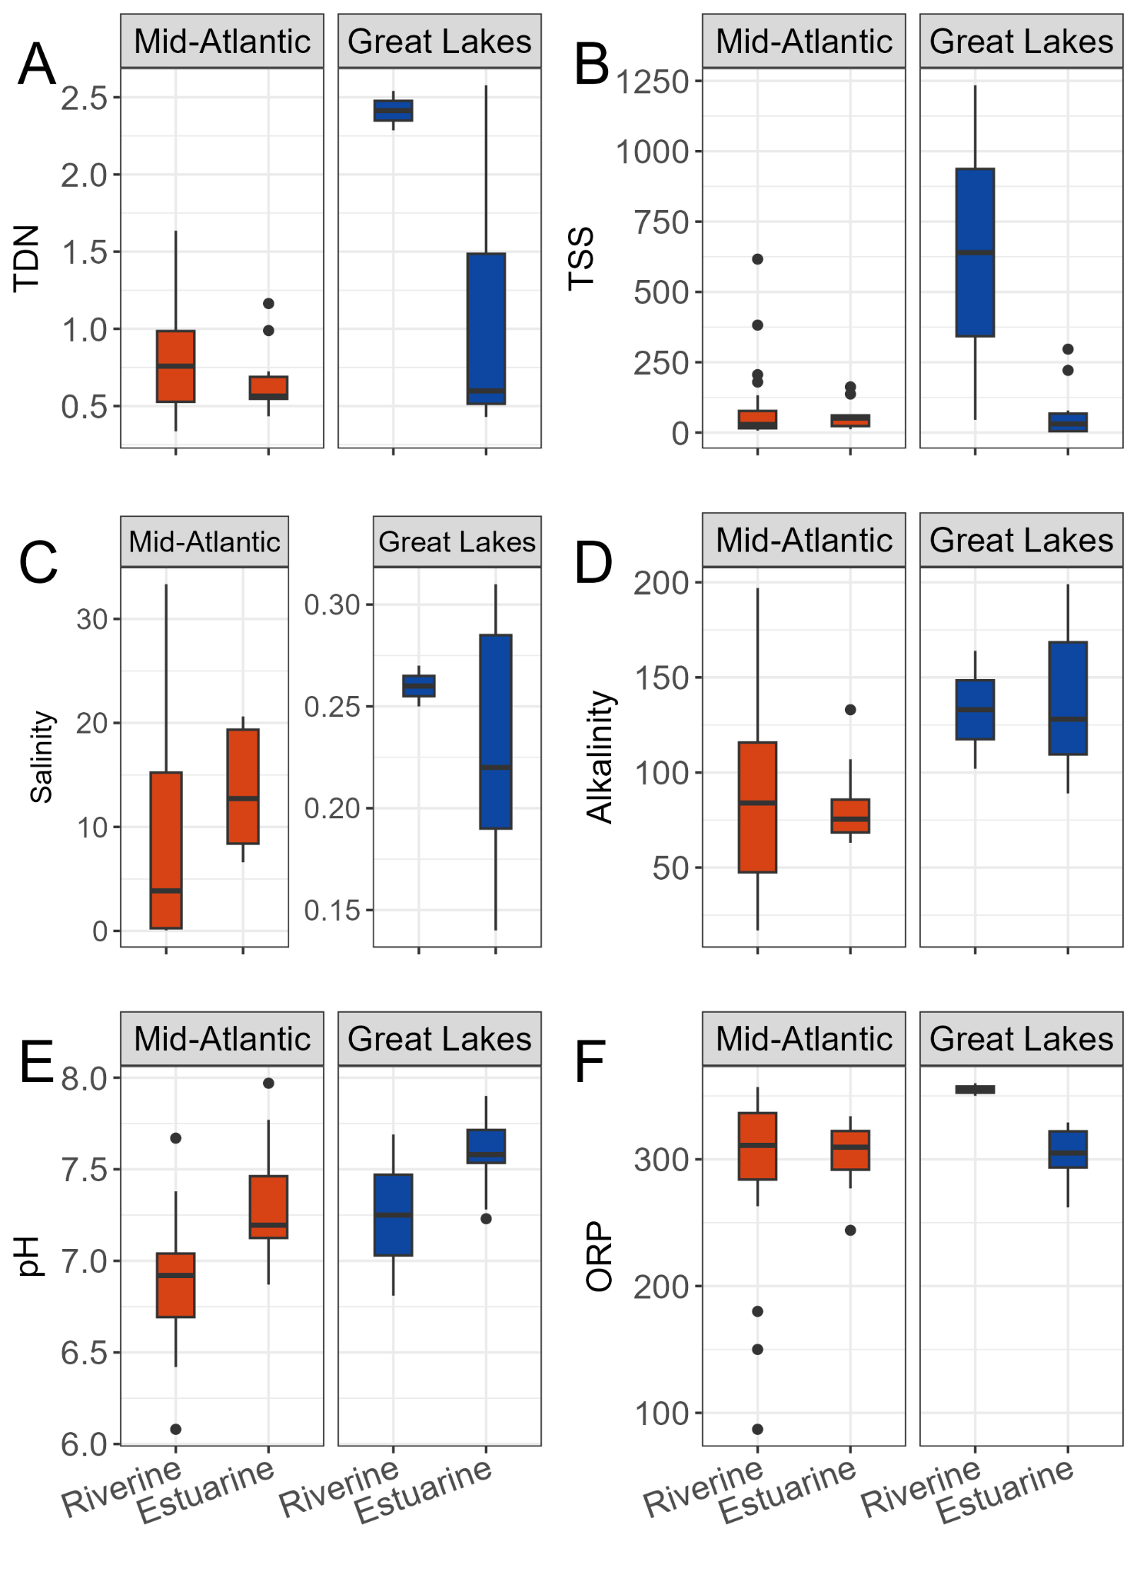

**Figure S1:** Boxplots displaying regional trends in water type for various water quality parameters including A) total dissolved nitrogen (TDN, mg/L), B) total suspended solids (TSS, mg/L), C) salinity (psu), D) alkalinity (mg/L CaCO3), E) pH and F) redox potential (ORP, mv)

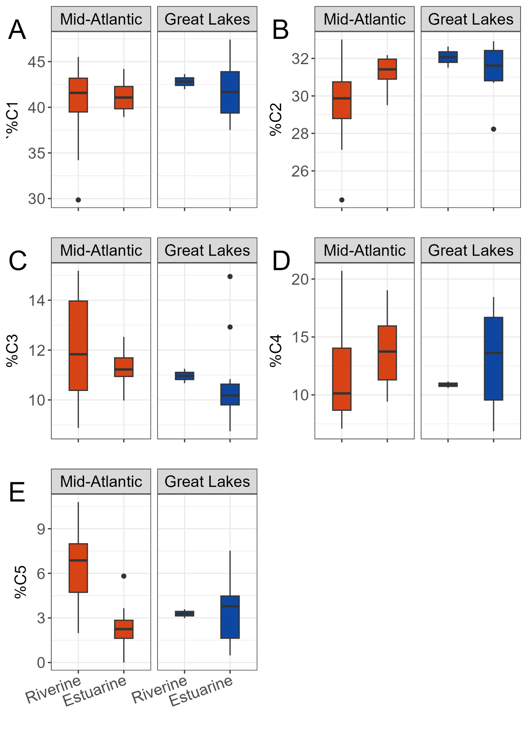

**Figure S2:** Boxplots displaying regional trends in water type for relative contributions of PARAFAC components including A) %C1, B) %C2, C) %C3, D) %C4, and E) %C5

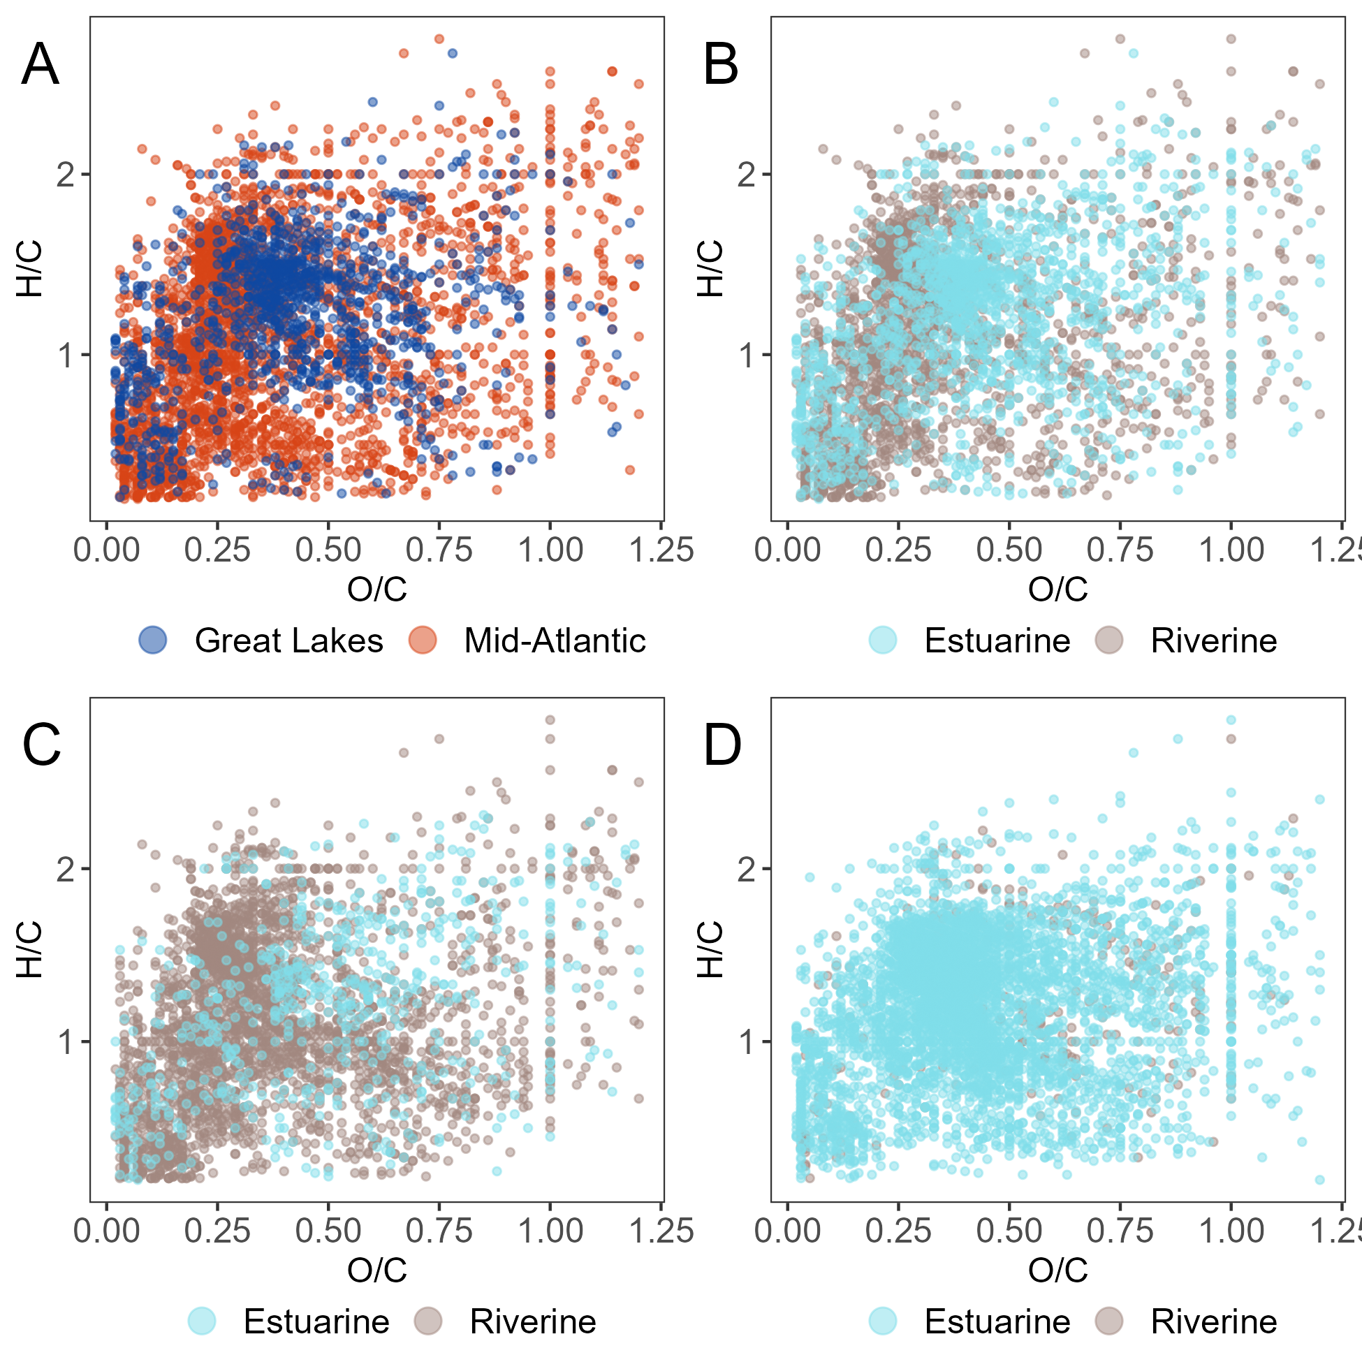

**Figure S3:** van Krevelen diagrams showing the unique formula across a) regions, b) water type, c) water type within the mid-Atlantic region, and D) water type within the Great Lakes region

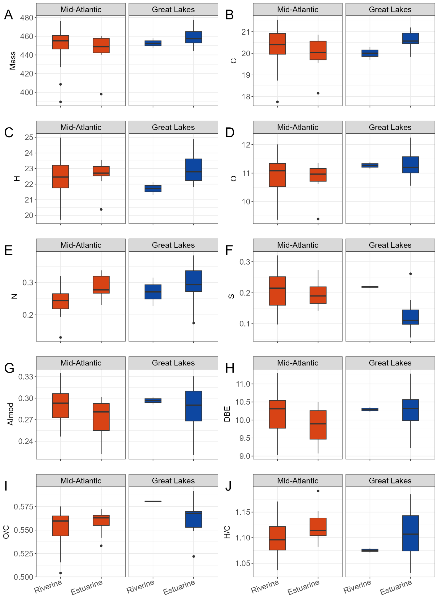

**Figure S4:** Boxplots displaying regional trends in water type for mean FTICR-MS molecular properties including A) mass (m/z), B) Carbon (C), C) hydrogen (H), D) oxygen (O), E) nitrogen (N), F) sulfur (S), G) modified aromaticity index (AImod), H) double bond equivalents (DBE), I) oxygen to carbon ratio (O/C), and J) hydrogen to carbon ratio (H/C)